**Chapter 3**

METHODOLOGY

This chapter contains the project design, program development, operation and testing procedure, and evaluation procedure.

**Project Design**

The project design is composed of the Context Level Diagram, the Data Flow Diagram, the Use Case Diagram, and the Entity Relationship Diagram of the system entitled Payroll System for Government Institutions Using Facial Recognition.

The system is designed to get the users attendance data using the daily time record module of the system through facial recognition and passing the data acquired to the payroll module of the system to generate an accurate paysheet and payslips of the employees.

In Figure 2, the employee will time in/out to the daily time record system through facial recognition and the recorded data will then be saved in the system which will be used by the payroll clerk as one of the basis to generate the paysheet. The employee could also update his employee profile by accessing his provided account. Also, all the attendance record, payslips generated, and the deductions/loans recorded could be viewed by the employee in his account.

The human resource personnel, aside from his rights as an employee in his account, files the leave approved, and the deductions/loans of the employee. In addition, the human resource personnel maintains the system by having the administrator rights in the employee accounts, departments, positions, holidays, and the customization of the system.

The payroll personnel, aside from his rights as an employee in his account, generates the paysheets every cut-off and the payslips every month.

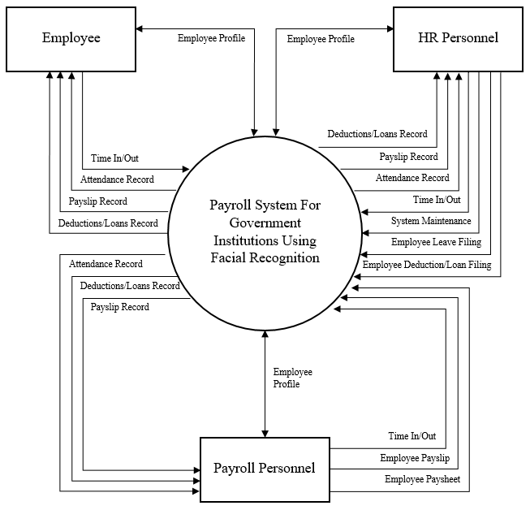

*Figure 2.* Context Level Diagram

In Figure 3, the employee could update his employee profile which are retrieved and saved at the employee table; the employee’s record of his time in/out is stored in timelog table of the database which is retrieved when the employee views his attendance in his account; and deductions/loans records and payslip records of the employee are retrieved at the deductions table and payslip and paysliploan table.

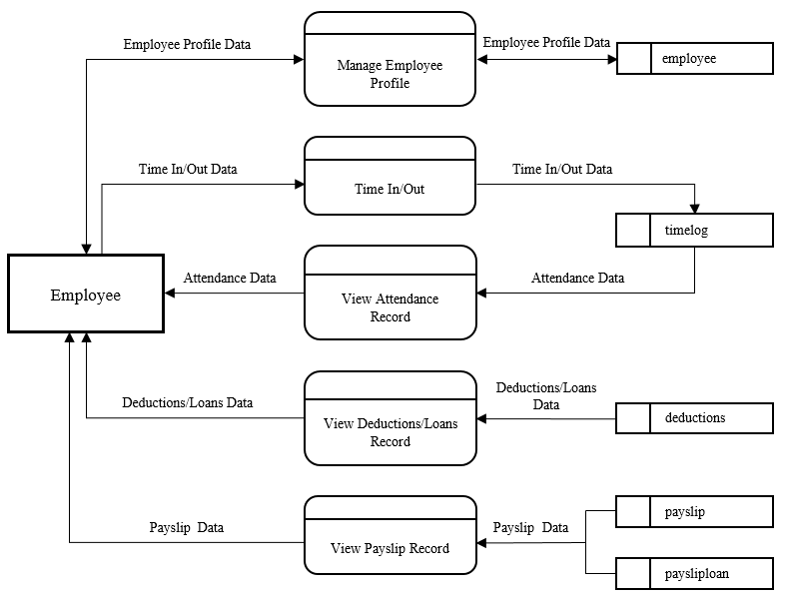

*Figure 3.* Employee DFD

In Figure 4, aside from his rights as an employee in his account, the human resource personnel files the leave approved by getting the leave category at the leave table and stored it at the leavehistory table, and the deductions/loans of the employee that is stored at the deductions table. In addition, the human resource personnel maintains the system by having the administrator rights in the employee accounts at the employee table, departments ata the department table, positions at the posotions table, holidays at the holidays table, and the customization of the system at the company_profile table.

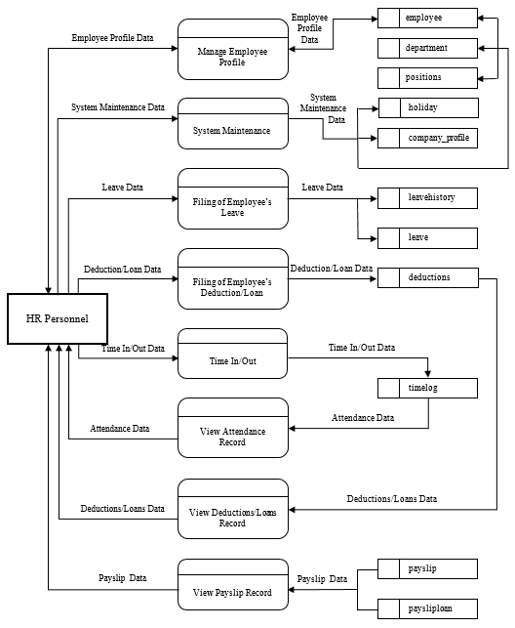

*Figure 4.* Human Resource DFD

In Figure 5, the payroll personnel, aside from his rights as an employee in his account, generates the paysheets every cut-off that is stored at the paysheet and payhsheetloan table, and the payslips every month that is stored at the payslip and paysliploan table.

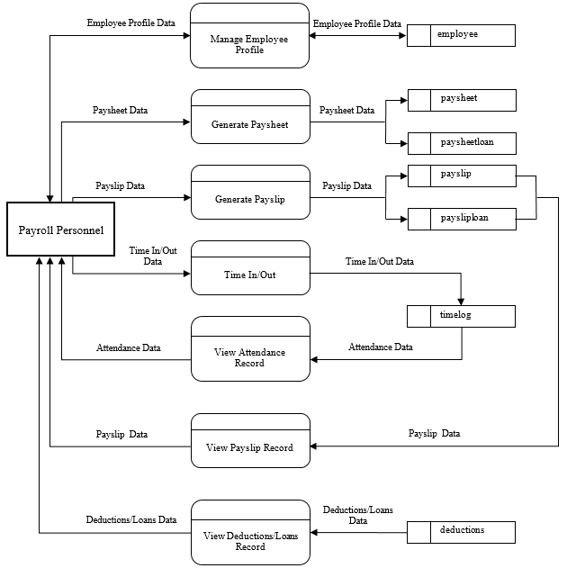

*Figure 5.* Payroll Personnel DFD

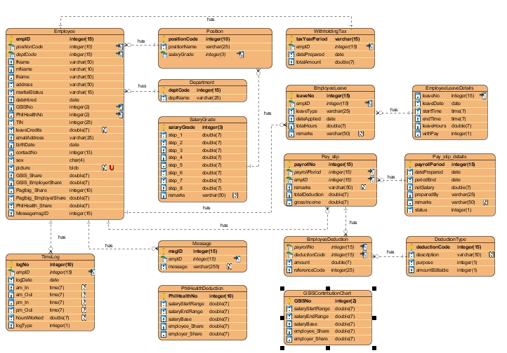

*Figure 6.* Entity Relationship Diagram

**Project Development**

The project development consists of a set of related activities that leads to the production of the system. The researchers chose the Agile Scrum Methodology Approach in developing the proposed system, the Payroll System for Government Institutions using Facial Recognition, as it produces a higher productivity and a better-quality product by allowing the project participants to adjust their activities in response to situations that arise during the project management process.

The Scrum methodology is defined by team roles, events (ceremonies), artifacts, and rules.

*Scrum Teams*

Scrum teams are typically composed of 7 +/- 2 members and have no team leader to delegate tasks or decide how a problem is solved. The team as a unit decides how to address issues and solve problems. Each member of the Scrum team is an integral part of the solution and is expected to carry a product from inception to completion. There are three key roles in a Scrum team:

*The Product Owner.* The Product Owner is the project’s key stakeholder – usually an internal or external customer, or a spokesperson for the customer. There is only one Product Owner who conveys the overall mission and vision of the product which the team is building. The Product Owner is ultimately accountable for managing the product backlog and accepting completed increments of work.

*The ScrumMaster.* The ScrumMaster is the servant leader to the Product Owner, Development Team and Organization. With no hierarchical authority over the team but rather more of a facilitator, the ScrumMaster ensures that the team adheres to Scrum theory, practices, and rules. The ScrumMaster protects the team by doing anything possible to help the team perform at the highest level. This may include removing impediments, facilitating meetings, and helping the Product Owner groom the backlog.

*The Development Team.* The Development Team is a self-organizing, cross-functional group armed with all of the skills to deliver shippable increments at the completion of each sprint. Scrum broadens the definition of the term “developer” beyond programmers to include anyone who participates in the creation of the delivered increment. There are no titles in the Development Team and no one, including the ScrumMaster, tells the Development Team how to turn product backlog items into potentially shippable increments.

*Scrum Events (Ceremonies)*

*The Sprint.* A sprint is a time-boxed period during which specific work is completed and made ready for review. Sprints are usually 2-4 weeks long but can be as short as one week.

*Sprint Planning.* Sprint Planning team meetings are time-boxed events that determine which product backlog items will be delivered and how the work will be achieved.

*The Daily Stand-up.* The Daily Stand-up is a short communication meeting (no more than 15 minutes) in which each team member quickly and transparently covers progress since the last stand-up, planned work before the next meeting, and any impediments that may be blocking his or her progress.

*The Sprint Review.* The Sprint Review is the “show-and-tell” or demonstration event for the team to present the work completed during the sprint. The Product Owner checks the work against pre-defined acceptance criteria and either accepts or rejects the work. The stakeholders or clients give feedback to ensure that the delivered increment met the business need.

*The Retrospective*. The Retrospective, or Retro, is the final team meeting in the Sprint to determine what went well, what didn’t go well, and how the team can improve in the next Sprint. Attended by the team and the ScrumMaster, the Retrospective is an important opportunity for the team to focus on its overall performance and identify strategies for continuous improvement on its processes.

*Scrum Artifacts*

*Product Backlog.* The product backlog is the single most important document that outlines every requirement for a system, project or product. The product backlog can be thought of as a to-do list consisting of work items, each of which produces a deliverable with business value. Backlog items are ordered in terms of business value by the Product Owner.

*Sprint Backlog.* A sprint backlog is the specific list of items taken from the product backlog which are to be completed in a sprint.

*Increment.* An Increment is the sum of all product backlog items that have been completed since the last software release. While it is up to the Product Owner to decide on when an increment is released, it is the team’s responsibility to make sure everything that is included in an increment is ready to be released. This is also referred to as the Potentially Shippable Increment (PSI).

*Scrum Rules*

The rules of agile Scrum should be completely up to the team and governed by what works best for their processes. The best agile coaches will tell teams to start with the basic scrum events listed above and then inspect and adapt based on your team’s unique needs so there is continuous improvement in the way teams work together.

**Operation and Testing Procedures**

This section is used to check if the system meets the criteria according to the systems functionality, accuracy, responsiveness and reliability. The researcher will conduct a test on the system as a part of the Operation and Testing Procedures.

**For Functionality Testing:**

1. The researcher will perform the Time In function by facing the camera.
2. If the system recognizes a match in its records. The system will automatically input the time of the process for the match’s Time In record for the current day.
3. The researcher will now perform the Log In function by entering the username and password, in order to check whether his time-in for the day was recorded.
4. If the entered credentials matches the information of any of the users: Employee, Payroll Personal, and HR Personnel, the system will automatically directed to his/her account.
5. In the Employee account, there will be Employee Profile, Attendance, Deductions and Payslip options.
6. The researcher will click Employee Profile and it will be directed to the page, he/she will be able to edit/update his/her own profile.
7. The researcher will click Attendance and it will be directed to the page, he/she will be able to view his/her daily attendance record up to the current day.
8. The researcher will click Deductions and it will be directed to the page, he/she will be able to view his/her Deduction records.
9. The researcher will click Payslip and it will be directed to the page, he/she will be able to view his/her payslip upto the recent payroll period.
10. In performing the Time Out function, the researcher will then face the camera again.
11. If the system recognizes a match in the records again. The system will automatically input the time of the process for the match’s Time Out record for the current day.

**For Accuracy Testing:**

1. The researcher will access the Attendance module.
2. The attendance record for each current day will display the time-in and time-out record of the user for each day, provided that it would be the same time as of when the user timed-in or timed-out his/her attendance.

**For Reliability Testing:**

1. The researcher will access the Paysheet module.
2. The paysheet record for each payroll period will display the exact amount of his/her salary. Provided that it will also display how that salary did came up depending on his/her attendance and deductions on the payslip.

**For Portability Testing:**

1. The researcher will access the site through a mobile device.
2. The researcher will logon to his/her account the same way he/she does it through a computer.
3. The researcher will check if the site is properly displayed through a mobile device.
4. The researcher will check his/her Attendance and Payslip to check if those modules are working properly just like on the web-based system.
5. The researcher will perform the Logout function.

**Evaluation Procedure**

*ISO 9126*

To measure the system’s performance, an evaluation instrument using ISO 9126 is used. The survey form can be found in the Appendix. The criteria are Functionality, Reliability, Usability, Maintainability, and Portability. The following are the steps done during the evaluation:

1. Evaluation forms is distributed to twenty seven (27) CS/IT/IS students and three (3) IT Professionals;
2. Prior to the completion of evaluation forms, the researchers demonstrated how to use the system to the group of evaluators composing of IT Professionals and CS/IT/IS students;
3. After the demonstration, the researcher asked the evaluators to use the intranet based system.
4. Finally, the evaluators will rate the system based on 4 Point Likert Scale. The response was chosen from a scale of 1 to 5, 5 being the highest which means Highly Acceptable, and 1 being the lowest which means Not Acceptable.

**Table 1**

*4 Point Likert Scale*

|  |  |
| --- | --- |
| Item |  |
| 4 | Highly Acceptable |
| 3 | Very Acceptable |
| 2 | Moderately Acceptable |
| 1 | Not Acceptable |

1. Data was tabulated to compute for the mean of each criterion and the overall mean computation for the given criteria.
2. In interpreting the results of the evaluation. The study used the Rating Scale for Interpreting the Evaluation Result.

**Table 2** – Rating Scale for Interpreting the Evaluation Result

|  |  |
| --- | --- |
| Item |  |
| 3.76 – 4.00 | Highly Acceptable |
| 2.76 – 3.75 | Very Acceptable |
| 1.76 – 2.75 | Moderately Acceptable |
| 1.00 – 1.75 | Not Acceptable |

*W3C*

The Markup Validation Service is a validator by the World Wide Web Consortium (W3C) that allows Internet users to check HTML and XHTML documents for well-formed markup. Markup validation is an important step towards ensuring the technical quality of web pages.

1. In *https://validator.w3.org/*, the evaluators validated by file upload